Install US Cyber Patriot Images

Download and Install VMware Workstation Player

I have a copy of Workstation Player on my laptop so you can get it quickly. If the entire class downloads individual copies of a large file simultaneously, it will use a lot of bandwidth. To connect to the file share on my laptop:

1. Open File Explorer, right click “This PC”, and select “Map Network Drive”.  
   Graphical user interface, application, Word

   Description automatically generated
2. Enter the share location the instructor puts on the board. It will be similar to this (note that the numbers will change where the xxx are):  
   \[\JohnLaptop\CyberPatriot](file:///\\172.xx.xx.xxx\cyberpatriot)  
   Note: the “slashes” are “back slashes”, the key above the Enter key. The one that is shift-question mark is a “forward slash.”  
   Check the box, “Connect using different credentials”, and click “Finish”.  
   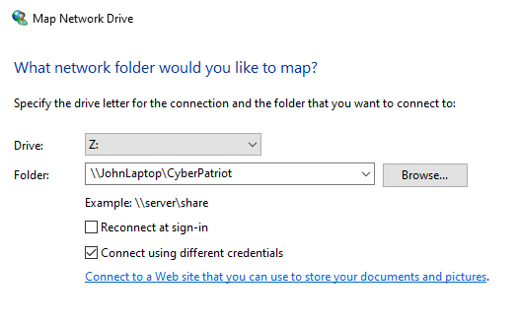
3. Enter svgs as the username and get the password from your instructor. Click “OK”.  
   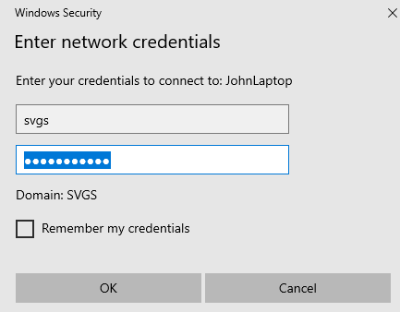
4. You should see a list of files in the CyberPatriot share.   
   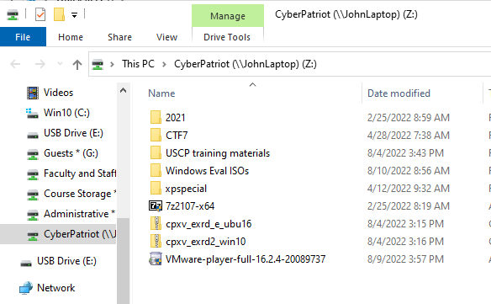
5. Copy the file, “VMware-player-full-…” to your desktop and double-click on it to start the installation.